Requesting SLA Blackouts

Service Level Management

Purpose

This procedure explains how to request an SLA blackout.

Related Policy
- IT Service Management Policy

Audience
The following groups are responsible for adhering to this document:
- Service Level Management
- JTS support groups
- Systems Innovation Group (SIG) groups

Procedure
Step | Responsible Action
1 | SIG/JTS When creating the Change Request, the following items should be addressed:  - Identify the duration of the SLA blackout period and add it to a word or notepad document. Blackout periods should be used for emergency or scheduled changes (deployment or conversion activities; hardware upgrades; network changes; or any other activities) that occur or extend outside the associated change window.  - Identify all applications that are impacted by the change and relate them as CI’s to the Change task.  - All impacted business units must sign off on the change request.
2 | Add the SLA blackout task to your Change Request:  - Use the following “assignee” information when creating the SLA blackout task:  - Assignee Company – PGDS US  - Assignee Organization – Service Delivery  - Assignee Group – Service Level Management  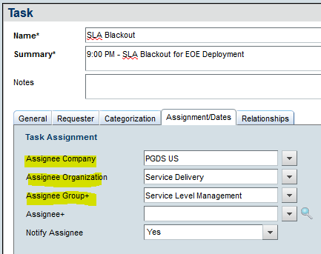  - The Remedy task for the blackout should be set up as the last task of the Change.  - Attach the information from Step 1.1 to the blackout task.  Note: Any change activity lasting beyond the requested SLA blackout window will count as a missed SLA.
3 | Service Level Use the information found in the Remedy task for SLA Blackout to apply a carve out Management to the SLA Report:  - Use the appropriate monitoring tool to verify that the error minutes that appear on the SLA report falls within the time frame stated in the attachment in the Remedy task.  - Only apply a carve out to the minutes that fall within the expected time frame.  - Add a comment to the SLA Report using the Change number and a brief summary of the change.

Workflow
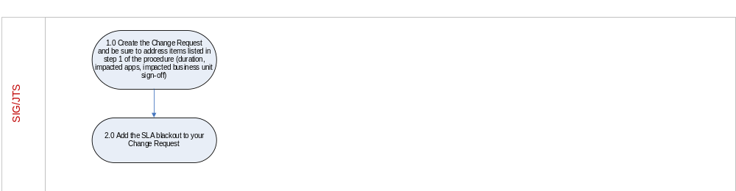

Modification
The following associates can make modifications to this document:
- Manager, Service Level Management
- Director, IT Service Management
- Vice President, Service Delivery, JTS
- Chief Technology Officer, JTS

Requesting SLA Blackouts
Responsible Party: Henry Branham, Service Level Management  Approving Authority: Anna Carter, Manager, Service Level Management | Last Modified Date: 19 DEC 2017

